1.
Draw a labelled diagram of a typical home WiFi router and a network switch, clearly marking at least 3 different ports (such as WAN, LAN, Console) and the location of status LEDs.
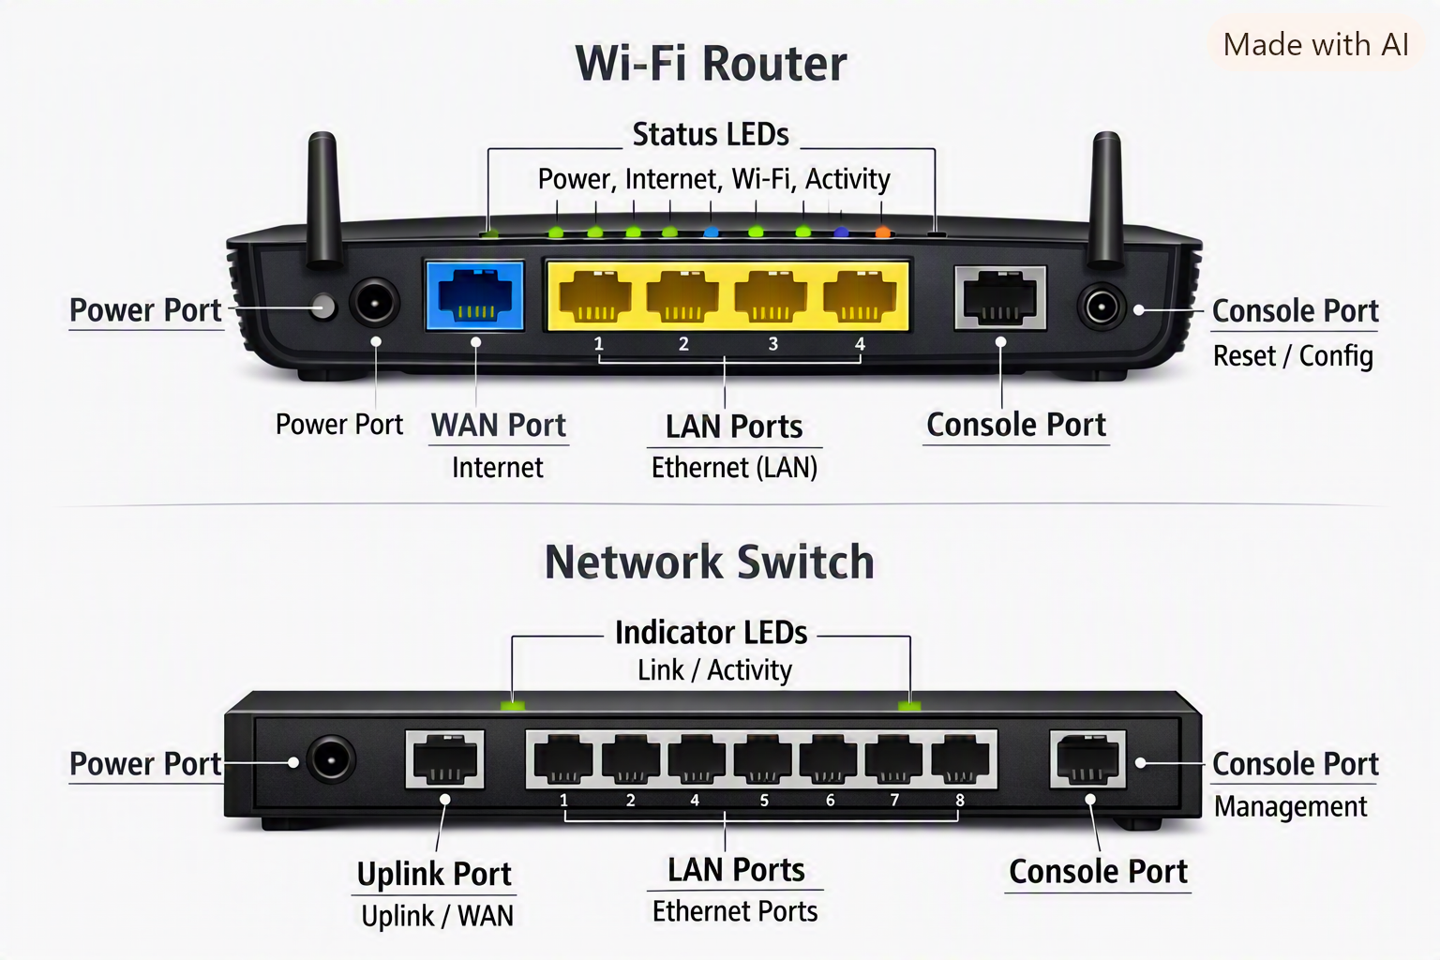

2.
List 3 key differences between routers and switches in terms of their main functions and how they handle network traffic.<br><br><em><strong>Hint:</strong> Think about how each device deals with IP addresses, MAC addresses, and the types of networks they connect.</em>
Aspect | Router | Switch
Main Function | Connects different networks (LAN ↔ WAN) | Connects devices within the same LAN
Address Handling | Uses IP addresses to route packets | Uses MAC addresses to forward frames
Traffic Management | Directs data between networks; performs NAT and DHCP | Filters and forwards data within one network segment

3.
Take a real or virtual image of a router and a switch (from your home, lab, or Google Images), and identify the following on each: Power port, at least 2 Ethernet ports, and any LED indicators. Annotate the image or describe their position and purpose.
Router
- Power Port: Round socket at the back, connects to adapter.
- WAN Port: Usually blue, connects to modem/ISP line.
- LAN Ports: Typically yellow, numbered 1–4 for wired devices.
- LED Indicators: On top/front — show power, internet, Wi-Fi, and activity status.
Network Switch
- Power Port: Round socket at one end.
- Ethernet Ports: 8–24 ports in a row, each with a small LED above showing link/activity
- LED Indicators: Green/orange lights blink when data is transmitted.

4.
Imagine you are setting up a small gaming café network for IPL streaming and multiplayer matches. Write a short scenario explaining which device (router or switch) you would connect first to the ISP line, and how you would connect 8 gaming PCs to the network. Justify your choices.
- Step 1: Connect the ISP line to the router’s WAN port.
  - The router will handle internet access, IP assignment (DHCP), and network security.
- Step 2: Connect the router’s LAN port to the switch’s uplink port.
  - The switch will distribute the connection to 8 gaming PCs via Ethernet cables.
- Step 3: Each PC connects to the switch using Cat6 Ethernet cables for high-speed, low-latency gaming.
Justification:
- The router manages external connectivity and IP addressing.
- The switch efficiently handles internal traffic among PCs, ensuring smooth gameplay and streaming

